Text 2
Text 1

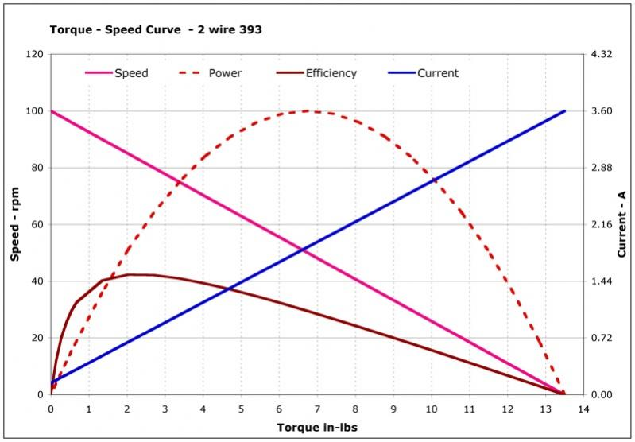
Fig – Torque v/s Speed characteristics

